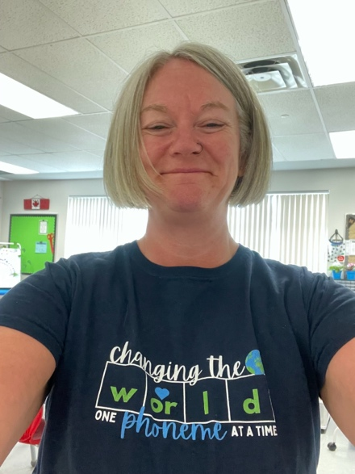
Hello everyone!

My name is Niki Beach, and I will be your instructor for the course. I am honoured to be born, live, work, explore and play on the unceded ancestral lands of the Lheidli T'enneh.

I was born and raised in Prince George and even attended CNC myself a VERY long time ago. I also attended UNBC and was one of 6 students in the first graduating class of 1994. I obtained a Bachelor of Arts in General Studies at UNBC, then attended UBC to graduate with a Bachelor of Education. Several years later, I completed a post bachelorette in Early Childhood Education from Queen’s University.

I taught Kindergarten in School District No. 57 for over 25 years and have recently transitioned into teaching English Language Learning to small groups of primary age students in my role of ELL teacher. I am passionate about literacy and particularly science-based structured literacy and equality for all our learners, especially our most vulnerable.

I have also had the pleasure of teaching my first CNC course this spring in the ECCL program and had the opportunity to observe students in practicum in the role of faculty advisor.

I am very excited to be teaching this course and will be learning as well as teaching. I am looking forward to connecting and exchanging multiple perspectives and experiences. My hope is that we will learn from each other, me included, based on our unique viewpoints and ideologies. I will challenge you to adopt a growth mindset and to think critically when engaging in group discussion and self-reflection.

Please reach out if you have any questions, beachn1@cnc.bc.ca.

Kind regards,

Niki Beach

